DAILY ONLINE ACTIVITIES SUMMARY

|  |  |  |  |  |  |  |
| --- | --- | --- | --- | --- | --- | --- |
| **Date:** | **26/06/2020** | | | **Name:** | **Rani M.D** | |
| **Sem & Sec** | **6th Sem & B Sec** | | | **USN:** | **4AL17CS075** | |
| **Pre-Placement Training Summary** | | | | | | |
| **Pre placement training** | **9:00 am to 11:00 am – Networks & Cyber Security**  **11:00 am to 1:00pm - Data Structures in C** | | | | | |
| **Faculty** | | **1.Dr. Manjunath Kotari**  **2. Mr. Venkatesh Bhat** | **Duration** | | | **4 hrs** |
| **Assessment** | | | | | | |
| **Problem Statement:**  **1.** Write a Java program to print all permutations of a given string. | | | | | | |
| **Status: Completed** | | | | | | |
| **Uploaded the report in GitHub** | | | **Yes** | | | |
| **If yes Repository name** | | | Daily Status | | | |
| **Uploaded the report in slack** | | | **Yes** | | | |

**Training snapshots:**

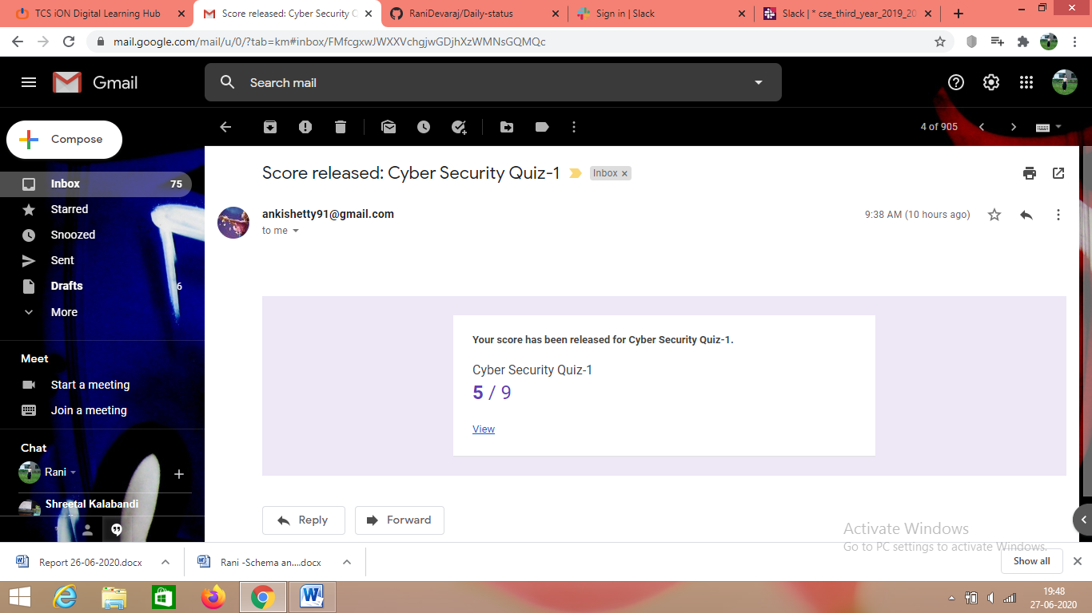

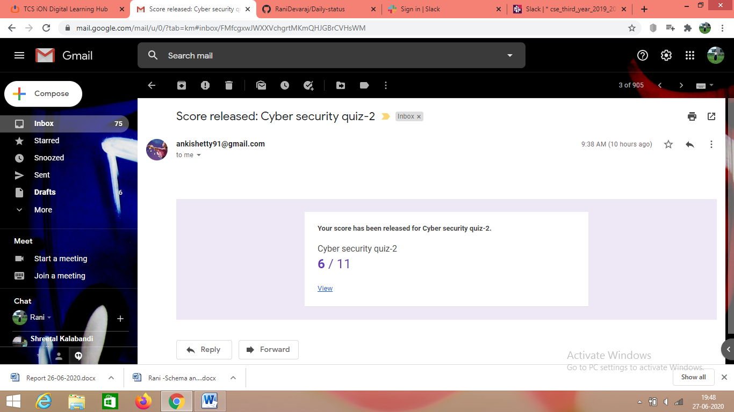

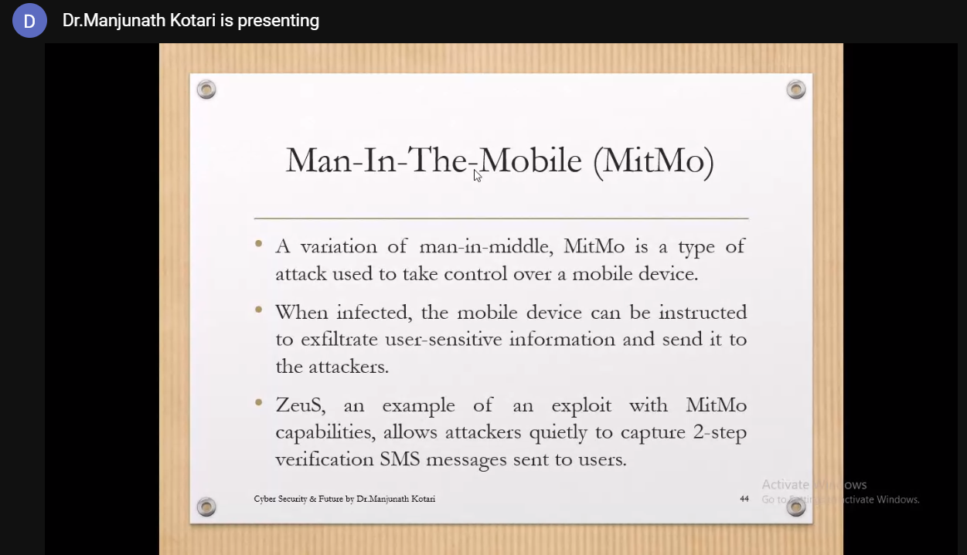

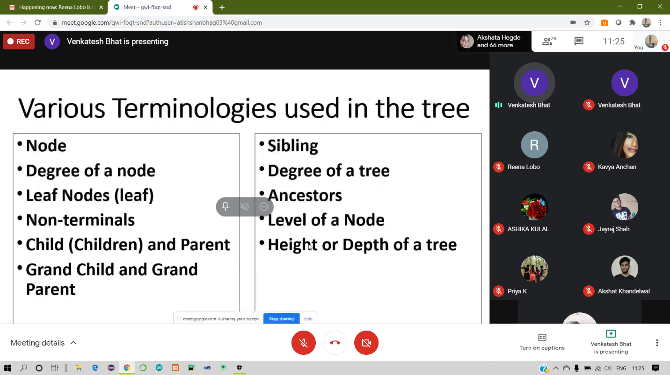

**Assessment:** Write a Java program to print all permutations of a given string.

